**Task-1**

**Make a report on:**

* How can AWS be used for data analytics, and what are the advantages of using AWS in this context?
* What AWS services are used in blockchain implementation?
* Describe the AWS services and tools that are commonly used for data analytics.
* What are the different data storage options provided by AWS for data analytics?
* Explain the concept of server less computing in AWS and its relevance to data analytics.
* Describe the security and compliance measures provided by AWS for data analytics workloads.
* What are some best practices for optimizing cost and performance in AWS data analytics deployments?
* Explain the concept of data governance in the context of AWS data analytics.
* How can AWS data analytics services be used in specific industries, such as retail, healthcare, or finance?
* How does AWS Personalize enable personalized recommendations and customer segmentation in data analytics applications?
* Explain the role of AWS IoT Analytics in processing and analyzing data from IoT devices for actionable insights.
* Explain the concept of data anonymization and the tools provided by AWS for privacy-preserving analytics.
* Discuss the integration of AWS Lambda and AWS Batch in serverless data processing and analytics workflows.

**Yash Dedania**

**Tasks:**

* How can AWS be used for data analytics, and what are the advantages of using AWS in this context?
* What AWS services are used in blockchain implementation?
* Describe the AWS services and tools that are commonly used for data analytics.

**1. How can AWS be used for data analytics, and what are the advantages of using AWS in this context?**

* **What is Data Analytics?**
* Data analytics converts raw data into actionable insights.
* It includes a range of tools, technologies, and processes used to find trends and solve problems by using data.
* Data analytics can shape business processes, improve decision-making, and foster business growth.
* **Workflow for doing Data Analysis**

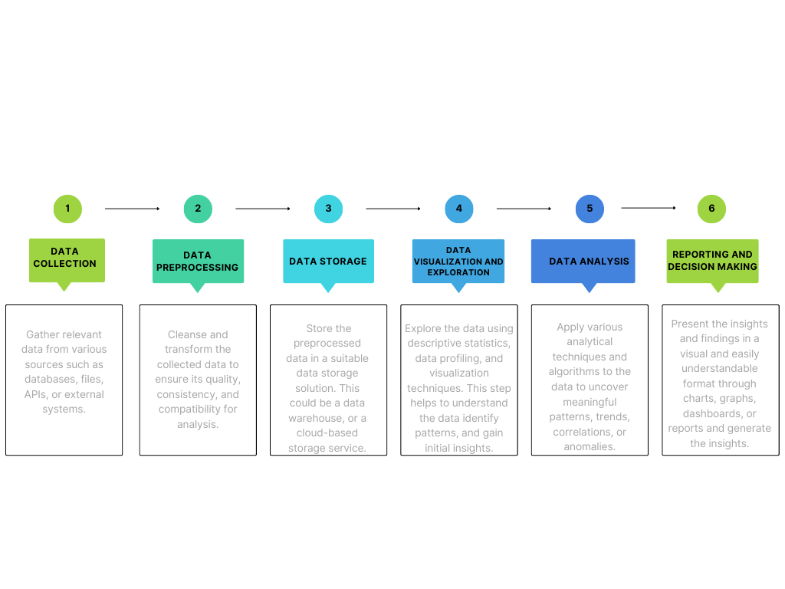

* **Where is data Analytics used for?**
* To reduce overall business costs
* Develop new and innovative products and services
* To predict Future sales or purchasing behaviors
* To help and Protect Against fraud
* To analyze the effectiveness of marketing campaigns
* To boost customer acquisition and retention
* To increase supply chain efficiently.
* **How can AWS be used for data analytics?**

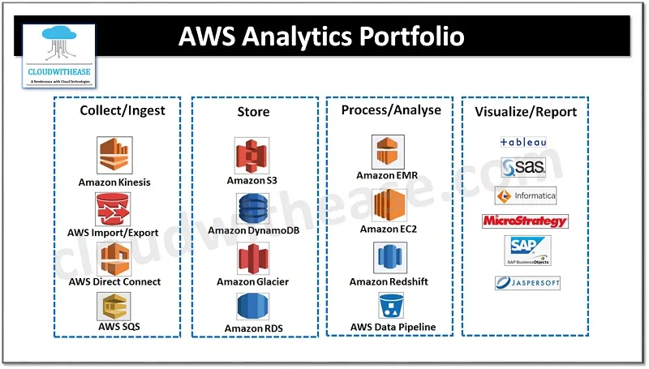

**Data collection / Ingestion :**

* **Amazon Kinesis** – Amazon Kinesis is a feature of Amazon Web Services (AWS) that easily gathers or collects, processes, and analyses video and data streams in a real-time environment. It has four components namely – Video Stream, data stream, data fire hose and data analytics. Amazon Kinesis Data Analytics is a new ML introduced to detect “hotspots” in the streaming data. A real time processing engine to write and execute SQL queries to have meaningful information from the data and you only pay for processing of resources that your streaming application is using.
* **AWS Import/Export** – AWS Import/Export service accelerates transfer of large amounts of data into and out of AWS using physical storage appliances, bypassing the Internet. Data is copied to a device (At source) and shipped via standard shipping mechanisms, and finally copied to (Destination).
* **AWS direct connect** – AWS Direct Connect links internal networks to an AWS direct Connect location over a standard Ethernet fibre-optic cable to achieve highly resilient network connections between Amazon Virtual Private Cloud (Amazon VPC) and their on-premises infrastructure.
* **AWS SQS** – Amazon SQS is a web service which gives access to message queues that store messages waiting to be processed making applications more flexible and reliable.

**Data Storage:**

* **Amazon S3** – easy to use and cheap storage service and can be used by S3 to store any amount of data for a wide range of use cases such as web hosting, data archival , software delivery and so on.
* **Amazon DynamoDB** – DynamoDB is a hosted NoSQL database offered by Amazon Web Services (AWS), reliable performance with scalability and managed experience.
* **Amazon Glacier** – is a data archiving solution.
* **Amazon RDS** – Relational Database Service which performs all these tasks (i.e., setup, operate, update) automatically

**Process / Analyse:**

* **Amazon EMR or Elastic MapReduce** is based on Hadoop/HDFS clusters, it is easy to use and fully managed, tightly integrated with S3.

* **Amazon RedShift** – is a columnar data warehouse, which is ANSI SQL compatible , fully managed and cost effective .
* **Amazon EC2** – is a web service that enables to launch and manage Linux /Unix and Windows server instances in Amazon data centres
* **AWS data pipeline** – is a web service to automate the movement and transformation of data

**Visualize / Report**

* The services/tools used to visualize or report are: Tableau, SAS, Informatica, MicroStrategy, SAP, Jaspersoft etc.
* **Workflow of AWS Analytics Services:**



* **Data Storage**: Use Amazon S3 (Simple Storage Service) to store your data securely and durably in the cloud.
* **Data Processing**: Utilize Amazon EMR (Elastic MapReduce) or AWS Glue for distributed data processing and transformation. EMR supports popular frameworks like Apache Hadoop and Spark, while AWS Glue offers serverless data integration and ETL (Extract, Transform, Load) capabilities.
* **Data Warehousing**: Leverage Amazon Redshift, a fully managed data warehouse service, to store and analyze large volumes of structured data efficiently. Redshift provides high performance and scalability for complex analytical queries.
* **Data Visualization and Exploration**: AWS QuickSight enables you to create interactive dashboards and visualizations from your data. It integrates with various AWS data sources and supports a wide range of visualization options.
* **Machine Learning**: AWS provides a suite of AI and ML services, such as Amazon SageMaker, which enables you to build, train, and deploy machine learning models for predictive analytics and data-driven insights.
* **Real-time Analytics**: AWS offers Amazon Kinesis, a platform for real-time streaming data analytics. With Kinesis, you can process and analyze streaming data from various sources, such as IoT devices or application logs.
* **Serverless Analytics**: AWS Athena allows you to query data directly from Amazon S3 using standard SQL queries without the need for managing infrastructure. It provides a serverless and cost-effective way to analyze large datasets stored in S3.
* **Data Catalog and Metadata Management**: AWS Glue provides a fully managed metadata catalog that helps discover, organize, and manage metadata for your data assets across various data sources.

**AWS Analytics Services Provides:**

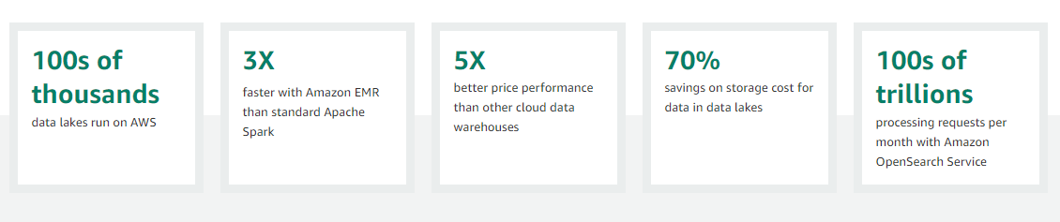

* **Advantages of using AWS in Data Analytics**
* **Scalability:** AWS offers a highly scalable infrastructure that can handle large volumes of data and accommodate fluctuating workloads. You can easily scale up or down your resources based on demand, ensuring optimal performance and cost efficiency.
* **Broad Range of Services**: AWS provides a comprehensive suite of services specifically designed for data analytics, including data storage, processing, warehousing, visualization, and machine learning. This eliminates the need to manage and integrate multiple tools from different vendors, streamlining the analytics workflow.
* **Cost Effectiveness**: AWS offers a pay-as-you-go pricing model, allowing you to only pay for the resources and services you actually use. This eliminates the need for large upfront investments and provides cost flexibility.
* **Security and Compliance**: AWS maintains a robust and secure infrastructure that adheres to industry best practices and compliance standards. With features like encryption, access control, monitoring, and auditing capabilities, AWS helps protect your data and ensures regulatory compliance.
* **Flexibility and Agility**: AWS provides a wide range of services and configurations, allowing you to choose the most suitable tools and technologies for your specific data analytics needs. This flexibility enables you to experiment, innovate, and adapt to changing requirements quickly and easily.
* **Integration with Other AWS Services**: AWS services are tightly integrated with each other, enabling seamless data movement and integration across different components of your analytics pipeline. This integration simplifies data workflows, improves data governance, and facilitates the development of end-to-end analytics solutions.
* **Global Infrastructure:** AWS has a global presence with data centers located in different regions worldwide. This allows you to store and process data closer to your users or comply with data sovereignty requirements.
* **Reliability and High Availability**: AWS infrastructure is designed for high availability and fault tolerance. It offers features such as automated backups, data replication, and load balancing, ensuring that your data analytics applications are highly reliable and resilient.

**2. What AWS services are used in blockchain implementation?**

* 25% of all Ethereum workloads in the world run on AWS.
* Enterprise customers for Hyperledger Fabric include Nestle, Sony Music, BMW, Sage, Guardian, DTCC, Workday, Klarna Bank, SGX, Legal & General, Splunk, Zilliant, Contura Energy, DVLA UK, and many more.

**AWS Blockchain Services Provides:**

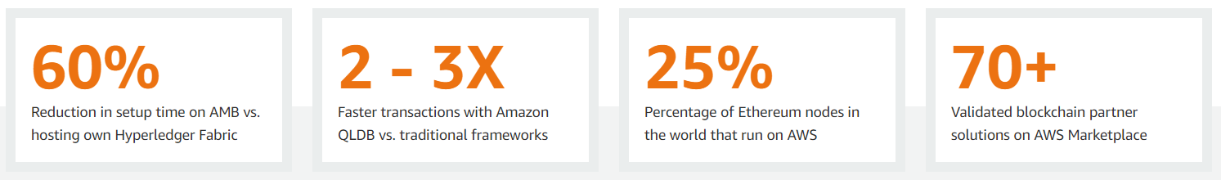

* **AWS Blockchain services**
* Amazon Quantum Ledger Database (QLDB)
* Amazon Managed Blockchain
* AWS Blockchain Partners
* **Amazon Quantum Ledger Database (QLDB):**

Amazon QLDB (Quantum Ledger Database) is a fully managed ledger database service provided by AWS that offers a centralized, immutable, and cryptographically verifiable transaction log. It is designed to provide transparent and tamper-proof storage for applications that require an authoritative and auditable record of all changes to their data.

**Functionality of QLDB:**

* **Immutable Transactions**: Once a transaction is committed to QLDB, it becomes an immutable part of the transaction history and cannot be altered or deleted.
* **Cryptographically Verifiable:** QLDB uses cryptographic hashing to create a unique hash for each transaction.
* **Centralized Ledger:** QLDB provides a single, centralized ledger that maintains a complete and transparent history of all transactions.
* **Scalability and Performance**: QLDB is designed to scale horizontally and handle high read and write throughput.
* **SQL-like Query Language:** QLDB supports a familiar SQL-like query language called PartiQL, which allows you to query and retrieve data from the ledger using standard SQL syntax.
* **Serverless Architecture:** QLDB is a serverless service, which means that you don't need to provision or manage any underlying infrastructure.
* **Integration with AWS Services:** QLDB can be integrated with other AWS services, such as AWS Lambda, Amazon S3, or AWS CloudTrail, to build end-to-end applications and leverage additional functionality.
* **Amazon Managed Blockchain:**

Amazon Managed Blockchain is a fully managed service provided by AWS that makes it easy to create and manage scalable blockchain networks using popular frameworks like Ethereum and Hyperledger Fabric.

**Functionality of Amazon Managed Blockchain:**

* **Network Creation and Management**: Amazon Managed Blockchain allows you to create and configure blockchain networks with just a few clicks. You can choose between Ethereum or Hyperledger Fabric frameworks, select the desired consensus algorithm, and define the network's configuration parameters.
* **Scalability and High Availability**: Managed Blockchain automatically scales the infrastructure to accommodate the needs of your network, ensuring high availability and performance.
* **Secure Network Access and Identity Management**: Managed Blockchain integrates with AWS Identity and Access Management (IAM) to manage network access and permissions.
* **Node Deployment and Management**: The service simplifies the deployment and management of blockchain nodes. It handles tasks such as node provisioning, peer configuration, and maintaining the network's shared ledger.
* **Monitoring and Logging**: Managed Blockchain integrates with Amazon CloudWatch for monitoring and logging. You can track network performance, view logs, and set up alerts to ensure the health and security of your blockchain network.
* **Integration with AWS Services**: Managed Blockchain seamlessly integrates with other AWS services. For example, you can store off-chain data in Amazon S3, trigger serverless functions with AWS Lambda, or integrate with databases like Amazon Aurora.
* **Secure and Reliable Infrastructure**: Managed Blockchain leverages AWS's robust infrastructure, which provides high security, durability, and availability. Data is encrypted at rest and in transit, and the service integrates with AWS Key Management Service (KMS) for secure key management.
* **AWS Blockchain Partners:**

AWS has a robust partner ecosystem that includes various blockchain partners. These partners offer specialized services, solutions, and expertise in implementing blockchain solutions on AWS.

Here are a few examples of AWS Blockchain Partners:

* ConsenSys
* R3
* IBM
* Chainyard
* Infosys
* Kaleido
* Splunk

**3. Describe the AWS services and tools that are commonly used for data analytics.**

* **Amazon S3 (Simple Storage Service):** Amazon S3 is a scalable object storage service that provides durable and cost-effective storage for large volumes of data. It is commonly used as a data lake to store raw and processed data for analytics.
* **Amazon Redshift:** Amazon Redshift is a fully managed data warehousing service that provides high-performance and scalable data storage and analysis. It is optimized for online analytical processing (OLAP) and is suitable for running complex queries on large datasets.
* **Amazon Athena:** Amazon Athena is an interactive query service that allows you to analyze data stored in Amazon S3 using standard SQL queries. It enables ad hoc analysis and exploration of data without the need for infrastructure setup or data loading.
* **Amazon EMR (Elastic MapReduce):** Amazon EMR is a big data processing service that provides a managed Hadoop framework, along with other popular frameworks like Apache Spark and Presto. EMR allows you to process and analyze large datasets using distributed computing.
* **AWS Glue:** AWS Glue is a fully managed extract, transform, and load (ETL) service that makes it easy to prepare and transform data for analytics. It offers automated schema discovery, data cataloging, and data transformation capabilities.
* **Amazon QuickSight:** Amazon QuickSight is a cloud-native business intelligence (BI) service that allows you to create interactive visualizations, reports, and dashboards from your data. It provides easy-to-use tools for data exploration and presentation.
* **AWS Lake Formation:** AWS Lake Formation is a service that simplifies the process of building and managing data lakes on AWS. It provides automated data ingestion, data transformation, and data security controls for setting up and managing data lakes.
* **AWS Glue DataBrew:** AWS Glue DataBrew is a visual data preparation tool that helps clean and normalize data for analysis. It offers a no-code interface for data wrangling tasks like data cleansing, normalization, and structuring.
* **Amazon Kinesis:** Amazon Kinesis is a platform for real-time streaming data ingestion and processing. It allows you to collect, process, and analyze streaming data from various sources for real-time analytics and insights.
* **Amazon Forecast:** Amazon Forecast is a fully managed service that uses machine learning to generate accurate forecasts based on historical data. It is commonly used for demand forecasting, inventory planning, and resource optimization.

AWS Analytics Services Used Commonly are:

